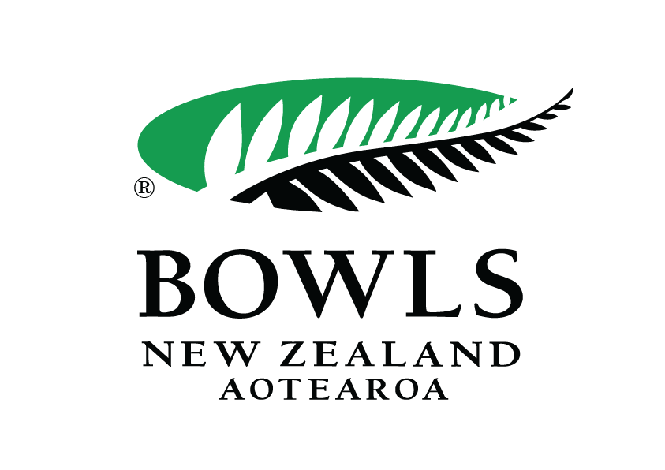
Bowls New Zealand
Vaccination Certificate Policy
5th November 2021
Bowls New Zealand prides itself on being an organisation that puts the health and safety of our community first by encouraging our members and staff to be vaccinated against COVID-19, so that we can reduce the risk of exposure and transmission of COVID-19. It is important that we provide our staff, members (and visitors) with a safe community, in which they can play bowls and enjoy our company. A safe community is a COVID-19-free community, and currently the best protection against spreading COVID-19 is vaccination.”

As a condition of entry to our workplace and events, anyone that enters our workplace or events aged 12 and over must:

agree to provide, written or electronic evidence of their COVID-19 vaccination certificate to the Bowls New Zealand representative, on request.

Variations to this condition of entry:

- Evidence of a COVID-19 vaccination received other than in New Zealand will be accepted if the evidence is standard in the relevant country, and it has been accepted by the Ministry of Health.

- A vaccination exemption has been granted by the Ministry of Health.

Bowls New Zealand reserves the right to restate its position as we learn and understand more about how New Zealand manages the fight against COVID-19 in our communities and workplaces. This policy is effective immediately and will be reviewed again by no later than 30th April 2022.

